**Welcome**

**To**

**My project**

* **Table of Contents; -**

1. Introduction to the topic
2. Need of ticket booking system
3. Advantages of ticket booking

System

1. Disadvantages of ticket booking system
2. Implementation in ‘C’ for ticket booking system
3. Discussion & Screenshots
4. Conclusion
5. Future Scope

**Introduction**

**to the topic**

Welcome to newly designed ticket booking system which is a faster, cleaner and a tad more, specially designed to make your booking experience better. Log on, navigate and find out for yourselves and if time permits leave your valuable feedback. The program automatically calculates the subtotal and grand total. When a visitor decides to finally book the ticket, the order information including the buyer's name, address and billing instruction is stored in the database securely and payment has been made.

Need of ticket booking

System

• **Efficiency**: Streamlines the booking process, reducing manual work and wait times for customers.

• **24/7 Availability**: Allows customers to book tickets anytime, improving accessibility.

**• Real-time Updates**: Provides instant updates on ticket availability and pricing, ensuring customers have the latest information.

• **User-Friendly Interface**: Enhances the customer experience with easy navigation and clear instructions.

• **Secure Transactions**: Ensures secure payment processing, protecting customer information.

• **Automated Confirmation**: Sends immediate booking confirmations via email or SMS, reducing customer anxiety.

• **Data Management**: Facilitates the collection and analysis of customer data, aiding in better marketing strategies.

• **Inventory Management**: Helps manage and track ticket sales and availability in real-time.

• **Customer Support**: Can include chatbots or automated responses to address customer inquiries quickly.

**• Cost-Effectiveness**: Reduces overhead costs associated with manual booking systems.

• **Scalability**: Easily accommodates increased demand during peak times or special events.

• **Integration with Other Systems**: Can be linked with other services (like travel or event management) for a comprehensive solution.

**Advantages of ticket booking system**

**Advantages of ticket booking system are as follows;->**

1. **Convenience;** **Users can book tickets anytime and anywhere, eliminating the need to visit a physical location.**
2. **Time-Saving: Online booking reduces wait times and allows users to quickly compare options and prices.**
3. **Accessibility:** It enables users to access information and book tickets 24/7, catering to different time zones and schedules.
4. **Real-Time Updates:** **Users can receive real-time information on availability, prices, and changes to their bookings.**
5. **Efficient Management: For businesses, a ticket booking system streamlines operations, managing inventory, sales, and customer data efficiently.**
6. **Enhanced User Experience: Features like easy navigation, filtering options, and payment gateways improve user satisfaction**
7. **Reduced Administrative Burden: Automation of booking processes minimizes the need for manual intervention, reducing errors and workload.**
8. **Data Analytics: Businesses can analyse booking patterns and customer preferences to tailor services and marketing strategies.**
9. **Security: Secure payment options protect customer information and enhance trust in the booking process**

**Disadvantages of ticket booking system**

**The disadvantages of ticket booking system are;->**

**• Technical Issues: System outages or glitches can disrupt the booking process, leading to frustration for users.**

**• Dependence on Technology: Users need access to the internet and a device, which may not be available to everyone.**

**• Limited Personal Interaction: The lack of face-to-face assistance can be a drawback for customers who prefer personal service or need help with complex bookings**

**IMPLEMENTATION OF THE CODE**

#include<stdio.h>

#include<conio.h>

#include<stdlib.h>

#include<string.h>

typedef struct{

char name[50];

int bus_num;

int num_of_seats;

}pd;

void reservation(void);

void viewdetails(void);

void printticket(char name[],int,int,float);

void specificbus(int);

float charge(int,int);

void login();

int main()

{

system("cls");

system("COLOR 0A");

printf("\t\t=================================================\n");

printf("\t\t| |\n");

printf("\t\t| ---------------------------------- |\n");

printf("\t\t| BUS TICKET RESERVATION |\n");

printf("\t\t| SYSTEM |\n");

printf("\t\t| ---------------------------------- |\n");

printf("\t\t| |\n");

printf("\t\t| |\n");

printf("\t\t| |\n");

printf("\t\t| |\n");

printf("\t\t| |\n");

printf("\t\t=================================================\n\n\n");

printf(" \n Press any key to continue:");

getch();

case 3:

return(0);

default:

printf("\nInvalid choice");

}

goto start;

return(0);

}

void viewdetails(void)

{

system("cls");

printf("---------------------------------------------------------------------------------------");

printf("\nBus.No\tName\t\t\tDestinations \t\tCharges \t\tTime\n");

printf("---------------------------------------------------------------------------------------");

printf("\n1001\tGodavari Travels \tDharan to Kavre \tRs.500 \t\t9:00 AM");

printf("\n1002\tDevit Travels \tKavre To Dharan \tRs.500 \t\t12:00 PM");

printf("\n1003\tHero Travels \tBenighat To Pokhara \tRs.450 \t\t1:50 PM");

printf("\n1004\tSuper Deluxe \tPokhara To Benigha \tRs.450 \t\t11:00 AM");

fflush(stdin);

gets(passdetails.name);

printf("\nEnter Number of seats:> ");

scanf("%d",&passdetails.num_of_seats);

printf("\n\n>>Press Enter To View Available Bus<< ");

getch();

system("cls");

viewdetails();

printf("\n\nEnter bus number:> ");

start1:

scanf("%d",&passdetails.bus_num);

if(passdetails.bus_num>=1001 && passdetails.bus_num<=1010)

{

charges=charge(passdetails.bus_num,passdetails.num_of_seats);

printticket(passdetails.name,passdetails.num_of_seats,passdetails.bus_num,charges);

}

else

{

printf("\nInvalid bus Number! Enter again--> ");

goto start1;

}

printf("\n\nConfirm Ticket (y/n):>");

start:

scanf(" %c",&confirm);

if(confirm == 'y')

{

fprintf(fp,"%s\t\t%d\t\t%d\t\t%.2f\n",&passdetails.name,passdetails.num_of_seats,passdetails.bus_num,charges);

printf("==================");

printf("\n Reservation Done\n");

printf("==================");

printf("\nPress any key to go back to Main menu");

}

else

{

if(confirm=='n'){

printf("\nReservation Not Done!\nPress any key to go back to Main menu!");

}

else

{

printf("\nInvalid choice entered! Enter again-----> ");

goto start;

}

}

fclose(fp);

getch();

}

float charge(int bus_num,int num_of_seats)

{

if (bus_num==1001)

{

return(500*num_of_seats);

}

if (bus_num==1002)

{

return(500*num_of_seats);

}

if (bus_num==1003)

{

return(450*num_of_seats);

}

if (bus_num==1004)

{

return(450*num_of_seats);

}

if (bus_num==1005)

{

return(400*num_of_seats);

}

if (bus_num==1006)

{

return(400*num_of_seats);

}

if (bus_num==1007)

{

return(350*num_of_seats);

}

if (bus_num==1008)

{

return(350*num_of_seats);

}

if (bus_num==1009)

{

return(600*num_of_seats);

}

if (bus_num==1010)

{

return(600*num_of_seats);

}

}

void printticket(char name[],int num_of_seats,int bus_num,float charges)

{

system("cls");

printf("-------------------\n");

printf("\tTICKET\n");

printf("-------------------\n\n");

printf("Name:\t\t\t%s",name);

printf("\nNumber Of Seats:\t%d",num_of_seats);

printf("\nbus Number:\t\t%d",bus_num);

specificbus(bus_num);

printf("\nCharges:\t\t%.2f",charges);

}

void specificbus(int bus_num)

{

if (bus_num==1001)

{

printf("\nbus:\t\t\tGodavari Travels ");

printf("\nDestination:\t\tDharan to Kavre");

printf("\nDeparture:\t\t9am ");

}

if (bus_num==1002)

{

printf("\nbus:\t\t\tDevit Travels ");

printf("\nDestination:\t\tKavre to Dharan");

printf("\nDeparture:\t\t12pm");

}

if (bus_num==1003)

{

printf("\nbus:\t\t\tHero Travels ");

printf("\nDestination:\t\tBenighat to Pokhara");

printf("\nDeparture:\t\t8am");

}

if (bus_num==1004)

{

printf("\nbus:\t\t\tSuper Deluxe ");

printf("\nDestination:\t\tPokhara to Benighat");

printf("\nDeparture:\t\t11am ");

}

if (bus_num==1005)

{

printf("\nbus:\t\t\tSai Baba Travels ");

printf("\nDestination:\t\tMaitidevi to Janakpur");

printf("\nDeparture:\t\t7am");

}

if (bus_num==1006)

{

printf("\nbus:\t\t\tShine On Travels ");

printf("\nDestination:\t\tJanakpur to Maitidevi ");

printf("\nDeparture:\t\t9.30am ");

}

if (bus_num==1007)

{

printf("\nbus:\t\t\tMayur Travels");

printf("\nDestination:\t\tHumla toJumla ");

printf("\nDeparture:\t\t1pm ");

}

if (bus_num==1008)

{

printf("\nbus:\t\t\tShree Travels ");

printf("\n Destination:\t\tJumla to Humla");

printf("\nDeparture:\t\t4pm ");

}

if (bus_num==1009)

{

printf("\nbus:\t\t\tKathmandu Express");

printf("\nDestination:\t\tKathmandu to Pokhara");

printf("\nDeparture:\t\t3.35pm ");

}

if (bus_num==1010)

{

printf("\nbus:\t\t\tSajha Yatayat");

printf("\nDestination:\t\tPokhara to Kathmandu");

printf("\nDeparture:\t\t1.15 ");

}

}

void login()

{

int a=0,i=0;

char uname[10],c=' ';

char pword[10],code[10];

char user[10];

char pass[10];

do

{

printf("\n ======================= LOGIN FORM =======================\n ");

printf(" \n ENTER USERNAME:-");

scanf("%s", &uname);

printf(" \n ENTER PASSWORD:-");

while(i<10)

{

pword[i]=getch();

c=pword[i];

if(c==13) break;

else printf("*");

i++;

}

pword[i]='\0';

i=0;

if(strcmp(uname,"deep")==0 && strcmp(pword,"deep")==0)

{

printf(" \n\n\n WELCOME TO OUR BUS RESERVATION SYSTEM !! YOUR LOGIN IS SUCCESSFUL");

printf("\n\n\n\t\t\t\tPress any key to continue...");

getch();

break;

}

else

{

printf("\n SORRY !!!! LOGIN IS UNSUCESSFUL");

a++;

getch();

system("cls");

}

}

while(a<=2);

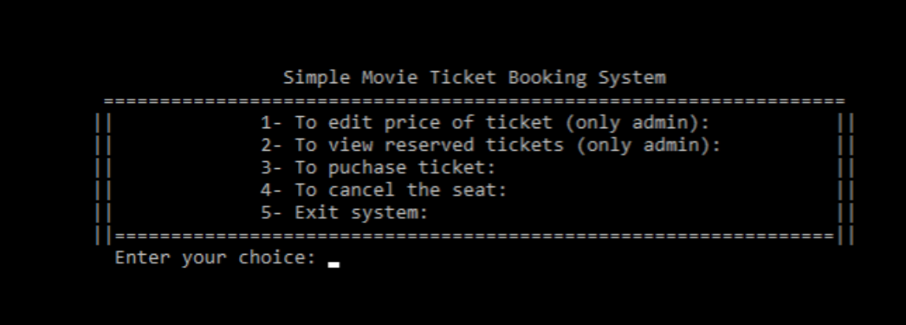**Discussions and screenshots**

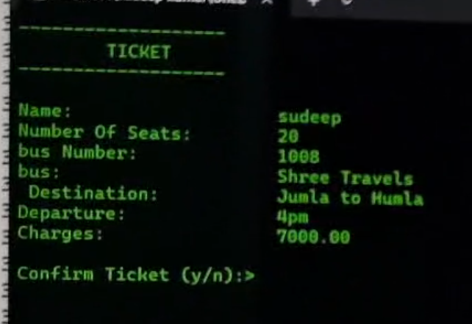

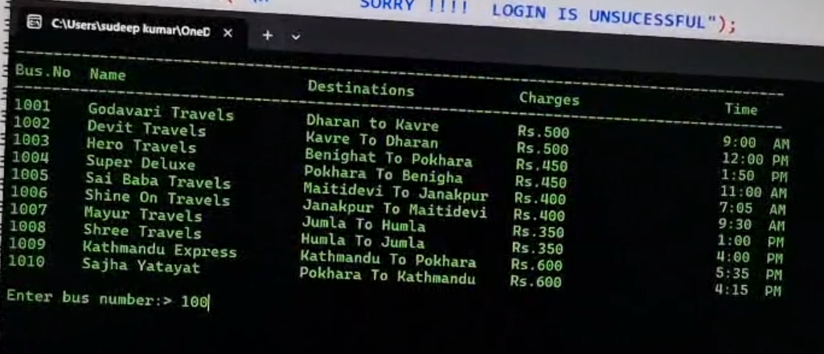

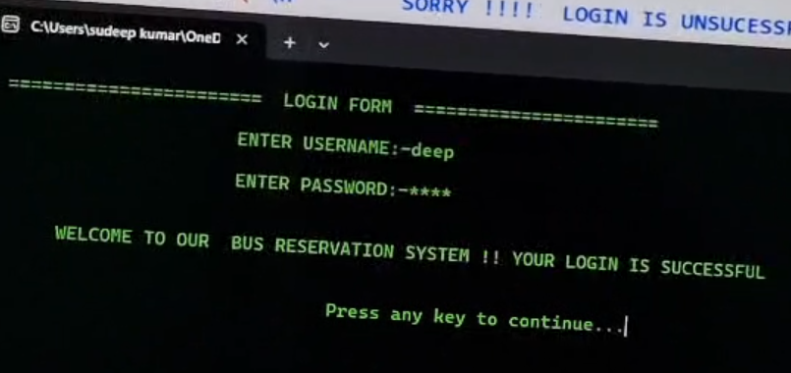

**Conclusion**

In conclusion, the Ticket Booking System developed offers an efficient, user-friendly platform for purchasing tickets for various events, services, or transportation. This system streamlines the process, allowing users to easily browse available options, select seats, make payments, and receive instant booking confirmations. Key features such as real-time availability, secure payment integration, and user account management ensure that customers have a seamless experience throughout the booking journey.

For administrators, the system offers powerful tools to manage events, track sales, and generate reports, ultimately contributing to better decision-making and enhanced operational efficiency.

In addition to the core functionalities, the system's scalability and adaptability allow it to accommodate future upgrades or integrate with additional features like mobile apps, loyalty programs, or dynamic pricing models. Overall, the Ticket Booking System meets the needs of both customers and administrators while ensuring high security, reliability, and performance. It stands as a robust solution capable of improving both customer satisfaction and business operations.

We hope that this system will continue to evolve and support the growing demand for seamless, online ticket booking experiences in various sectors.